
DEPARTMENT OF CSE
PROJECT ABSTRACT SUBMISSION
COURSE : COMPILER DESIGN
TITLE OF THE PROJECT | Digital Circuit Description Language
S. No. | University ID | Name
1 | 2420030055 | A Lahari
2 | 2420030113 | Harshini S R
3 | 2420030132 | P Priyanka

Abstract
Digital Circuit Description Language (DCDL) is a language designed to describe and represent digital circuits using simple, structured, and understandable statements. Digital circuits are essential components of modern electronic systems, including computers, calculators, communication devices, and embedded systems. Designing and representing these circuits involves defining logic gates, specifying input and output signals, and establishing connections between different components. When these operations are performed manually, the process can become complex and may lead to errors in circuit descriptions and logical connections. Therefore, the proposed project aims to develop a simple language that allows users to describe digital circuits in a structured format and process them using compiler design techniques.
The main purpose of DCDL is to combine the concepts of compiler design with digital circuit modelling. The system accepts circuit descriptions written in a predefined language and processes them through different phases of compilation. These phases include lexical analysis, syntax analysis, and semantic analysis. Each phase performs a specific function to ensure that the given circuit description follows the rules defined for the language. Lexical analysis identifies keywords, identifiers, operators, and symbols. Syntax analysis checks whether statements follow the correct grammatical structure, while semantic analysis verifies the logical meaning and correctness of circuit declarations.
The proposed language supports the description of basic digital logic gates such as AND, OR, and NOT, depending on the implemented features. These gates perform fundamental logical operations on binary inputs to produce outputs. Users can define input signals, output signals, gate operations, and connections between circuit components using simple statements. The system processes these statements and generates a structured representation of the described circuit. This representation helps users understand how the logic gates are connected and how the circuit operates.
Another important feature of DCDL is error detection and validation. The system checks input descriptions for invalid statements, incorrect syntax, undeclared signals, duplicate declarations, and other errors supported by the implementation. When an error is identified, the system can display an appropriate error message to help users understand and correct the problem. This process improves the reliability of circuit descriptions and reduces the effort required to identify mistakes manually. The types of errors detected depend on the validation rules implemented in the project.

Project report headings

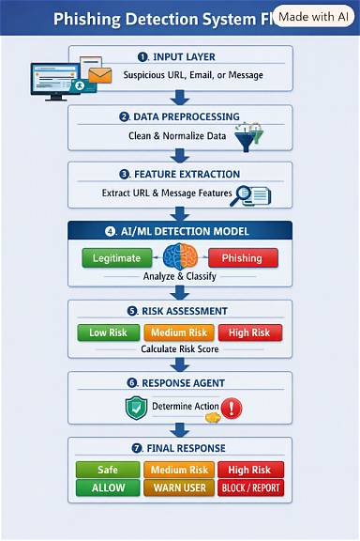
Basic flow of the project:

Circuit Description Input
↓
Lexical Analysis
↓
Syntax Analysis
↓
Semantic Analysis
↓
Circuit Validation
↓
Internal Circuit Representation
↓
Validated Circuit Output
Results
The results of the project show how compiler design techniques can be applied to digital circuit descriptions in a structured manner. The system processes the input through lexical, syntax, and semantic analysis and checks whether the circuit description follows the defined rules. Valid descriptions can be converted into an internal circuit representation, while supported errors such as invalid syntax, undeclared signals, or duplicate declarations can be identified during validation. These results help make circuit descriptions easier to understand and reduce errors before further circuit processing. The actual output depends on the language rules and validation features implemented in the project.
Overall, Digital Circuit Description Language aims to simplify the process of digital circuit description, improve error identification, and make basic digital logic concepts easier to understand. The project is useful for students, beginners, and developers who want to explore the relationship between compiler construction and digital circuit design. Future enhancements may include support for additional logic gates, complex circuits, graphical circuit visualization, truth-table generation, and circuit simulation.

